- The correct answer is:

C. 1,800

- The correct answer is:

  - 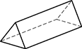

- The correct answer is:

D. Kelly, Lorinda, and Tanya

- The correct answer is:

C. 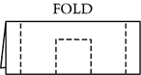

- The correct answer is:

B. F and G

- The correct answer is:

D. 11 ½ inches

- The correct answer is:

D. Divide 1,000 by 10.

- Sample Correct Response: Path B 3 centimeters

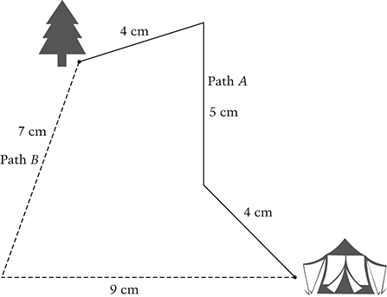

Path A:

Path B:

Correct

Answers path B and 3 centimeters (accept 2.9 to 3.1 cm)

Partial 1

Answers path A with 3 centimeters, with or without showing lengths of segments

(If work is shown and reflects an obvious mistake, then the response is scored as Incorrect 2.)

Partial 2

Answers path B with 16 on the answer line

Partial 3

Correctly measures each segment on path or labels total length of path A and path B (it must be clear which numbers go with the paths by showing lengths next to the path or by showing lengths of segments)

The difference in length may or may not be correct based on the measurements shown

Partial 4

Measures 4 of the 5 segments correctly and has correct difference in length based on these measurements

Incorrect 1

Answers path B with 2 on the answer line, with or without work

(This assumes the result is from computing 75. If work is shown and reflects an obvious mistake, then the response is scored as Incorrect 2.)

Incorrect 2 - All other incorrect responses

- The correct answer is:

C.

- Sample Correct Response: A line segment with a length of inches (accept responses from to , inclusive).

Correct 1 - Correct response

Correct 2 - Draws a line segment inches long BUT does not start at point A

Incorrect 1 - Draws a line segment centimeters long

(Accept responses between 7.3 and 7.7 cm, inclusive)

Incorrect 2 - Draws two or more line segments with total length of inches

Incorrect 3 - All other incorrect responses

- The correct answer is:

C.

- Sample Correct Response: 2,025 or 2025

Correct - Correct response

Partial 1 - Shows correct composition of numbers of buttons, but has one addition error in finding total number of buttons

Partial 2 - Work shows that 3 of the 4 place values are correct in the student's composition, and the student correctly adds the 4 numbers they obtained

Incorrect - Incorrect response

- Sample Correct Response: B is placed so that segment AB is 2 inches

Answer: 2 inches

Correct - Correct response

Partial - Incorrectly places point B

BUT correctly measures segment AB in inches, based on the incorrect placement of point B
OR
b. Correctly places point B so that segment AB is 2 inches
BUT does not answer 2 inches for the length of segment AB
OR
c. States that measure of segment AB is 2 inches, but does not mark point B on line segment

Incorrect - Incorrect response

- The correct answer is:

D. 53 mm

- Sample Correct Response: Rule: Differences keep increasing by one.
OR
Add 1, add 2, add 3, and so on.

New Pattern: 21, 22, 24, 27, 31, 36

Extended - Explanation for rule is correct, clear, and complete and does not mention repeating the pattern of numbers being added; Correct and complete new pattern (21, 22, 24, 27, 31, 36)
OR
b. Explanation for rule is correct, clear, and complete and does mention repeating the pattern of numbers being added; Correct and complete new pattern with repeating (21, 22, 24, 27, 31, 32)

Satisfactory - Explanation for rule is incomplete or unclear; Correct and complete new pattern (21, 22, 24, 27, 31, 36)
OR
b. Explanation for rule is correct, clear, and complete; There is one error in applying rule to new pattern
OR
c. There is one minor mistake in rule/explanation; Correct and complete new pattern (21, 22, 24, 27, 31, 36)

Partial - Incorrect rule/explanation or no rule/explanation;
a. Correct and complete new pattern (21, 22, 24, 27, 31, 36)
OR
b. Explanation for rule is correct, clear, and complete; New pattern is incorrect (there is more than one error) or not given
OR
c. There is one minor mistake in rule/explanation; New pattern correctly follows student's rule
OR
d. Explanation for rule is incomplete or unclear and/or has one minor mistake; There is one error in applying rule to new pattern

Minimal - Incorrect rule/explanation or no rule/explanation; Pattern may contain one error in applying student's rule or correct rule to new pattern
OR
b. Explanation for rule is incomplete or unclear; New pattern is incorrect (there is more than one error; new pattern may or may not relate to student's rule) or not given
OR
c. There is one minor mistake in rule/explanation; There is more than one error in applying student's rule to new pattern or new pattern is not given

Incorrect - Incorrect response

