Name _________________________________________________

Students will need a ruler with standard and metric markings.

1.

A. 180

B. 360

C. 1,800

D. 3,600

2. Kyle makes a 3-dimensional shape using 3 rectangles and 2 triangles as the faces. Which of these could be his shape?

A. 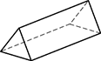

B. 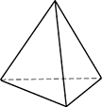

C.

D. 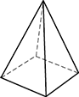

50-YARD-RACE
Girl | Time (seconds)
Christa | 8.28
Kelly | 7.82
Lorinda | 7.9
Sonja | 8.31
Tanya | 8.2

3. The table shows the times for five girls who ran a 50-yard race. The goal was for each girl to run the race in less than 8.25 seconds. Which girls met this goal?

A. Christa and Sonja

B. Christa and Tanya

C. Kelly, Lorinda, and Sonja

D. Kelly, Lorinda, and Tanya

4. Which figure below, when cut on the dotted lines and unfolded, will look like the figure shown above?

A. 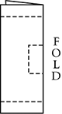

B. 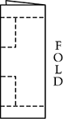

C. 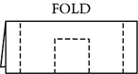

D. 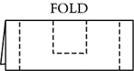

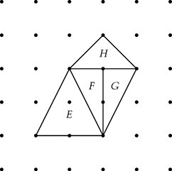
5. Which two figures are congruent?

A. E and H

B. F and G

C. F and H

D. G and H

6. (Use inches for this question.) What is the perimeter of the figure?

- 9 inches
- 10 ½ inches
- 11 inches
- 11 ½ inches

7. Which of these operations will give the smallest answer?

A. Subtract 1 from 1,000.

B. Multiply 1,000 by 1.

C. Divide 1,000 by 1.

D. Divide 1,000 by 10.

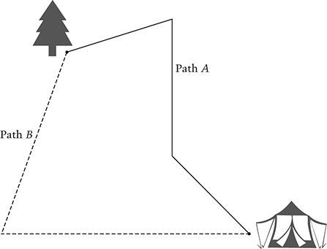
8. (Use centimeters in this question.) Which path from the tree to the tent is longer, path A or path B?

Answer: _____________

How much longer?

Answer: ___________ centimeters

9.

A.

B.

C.

D.

10. (Use inches for this question.) Start at point A. Draw a line segment that is inches long.
DRAW YOUR LINE SEGMENT IN THE BOX.

11. Lisa sold 15 cups of lemonade on Saturday and twice as many on Sunday. Which expression represents the total number of cups of lemonade she sold on both days?

A.

B.

C.

D.
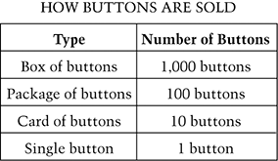
12. The art teacher bought buttons for a project. The teacher bought 1 box, 9 packages, 12 cards, and 5 single buttons. How many buttons did the teacher buy altogether?

Answer: _____________________ buttons

13. (Use inches for this question.) On line segment AC, mark point B so that the distance from A to B is twice the distance from B to C. How long is segment AB?

Answer: ___________________ inches

14. (Use millimeters for this question.) What is the length of the key in millimeters (mm)?

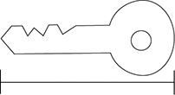
A. 5 mm

B. 8 mm

C. 50 mm

D. 53 mm

3, 4, 6, 9, 13,

15. The growing number pattern above follows a rule. Explain the rule.

Write a new growing pattern beginning with 21 that follows the same rule.

21, _______, _______, _______, _______, _______

