- Item Detail for Question 1 - No student responses are available for this question.

- Item Detail for Question 2 - No student responses are available for this question.

- Item Detail for Question 3

COMPLETE - Student Response
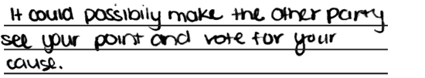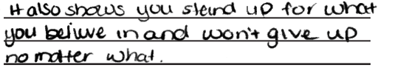

-------------------------------------------------------------------------------------------------------------------------------------------------------------------------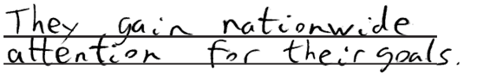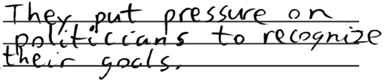

The response gives two valid ways that marches and demonstrations can achieve political goals.The response gives two valid ways that marches and demonstrations can achieve political goals.

PARTIAL - Student Response
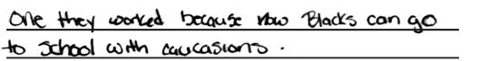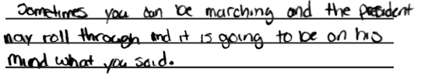

-------------------------------------------------------------------------------------------------------------------------------------------------------------------------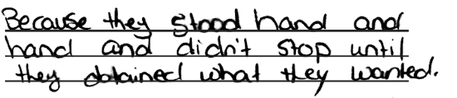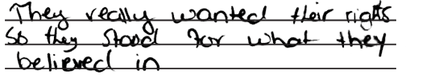

The response gives one valid way that marches and demonstrations can achieve political goals: make the president aware. The first way suggested in unacceptable because it lists a result of civil rights marches rather than a way that public demonstrations can achieve goals.The response gives only one valid way that marches and demonstrations can achieve political goals, but says it in two slightly different ways.

UNACCEPTABLE - Student Response
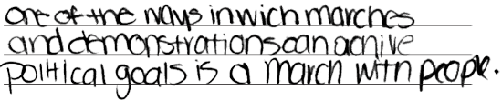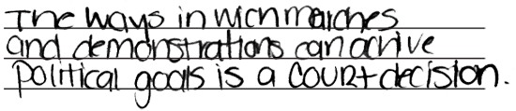

-------------------------------------------------------------------------------------------------------------------------------------------------------------------------

The response does not provide any creditable way that marches and demonstrations can achieve political goals. The first answer, "a march with people," does not make sense, and the second, "a court decision," does not explain any connection between marches and court decisions.The response does not give any ways that marches can achieve political goals. Both answers are vague and no clear connections are offered between the suggested actions and the achievement of political goals.

- Item Detail for Question 4 - No student responses are available for this question.

- Item Detail for Question 5 - No student responses are available for this question.

- Item Detail for Question 6 - No student responses are available for this question.

- Item Detail for Question 7

COMPLETE - Student Response

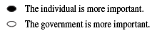
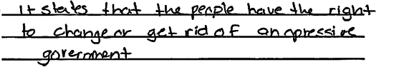
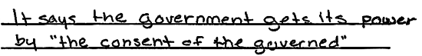

-------------------------------------------------------------------------------------------------------------------------------------------------------------------------

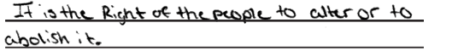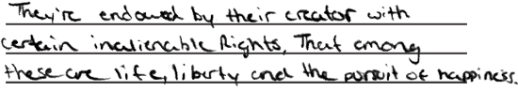

The response has correctly identifies the individual as being more important and gives two good reasons based on the text.The response correctly identifies the individual as being more important and gives two good reasons which, in this case, are taken directly from the text of the Declaration of Independence.

ACCEPTABLE - Student Response

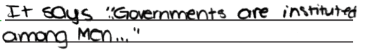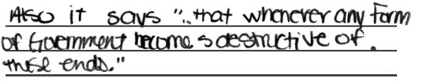
-------------------------------------------------------------------------------------------------------------------------------------------------------------------------
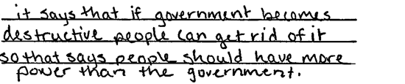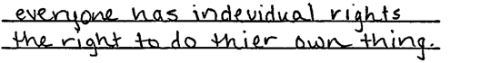

The response correctly identifies the individual and gives one acceptable supporting reason. The second reason, "that whenever any form of government becomes destructive of these ends,"omits the critical phrase, "it is the right of the people to alter or to abolish it," and therefore receives no credit.The response correctly identifies the individual and gives one acceptable supporting reason. In the second reason, "individual rights" is too vague; the answer needs to specify the rights or explain that they are "unalienable."

PARTIAL - Student Response

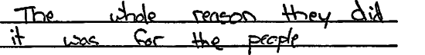
-------------------------------------------------------------------------------------------------------------------------------------------------------------------------

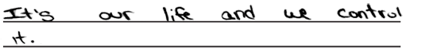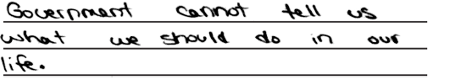

The response correctly identifies the individual as being more important but provides no acceptable support or reference to the Declaration.The response correctly identifies the individual as being more important but the reasons show a misunderstanding of the relationship between individuals and the government and provide no reference to the Declaration.

UNACCEPTABLE - Student Response

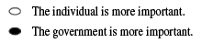

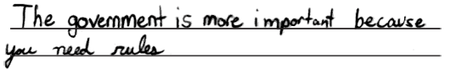
-------------------------------------------------------------------------------------------------------------------------------------------------------------------------
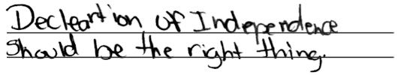
The response incorrectly concludes that the government is more important, and provides no valid reasons based on the Declaration of Independence. The student may believe that the government is more important because it can provide rules and principles, but those are not ideas contained in the text.The response provides incorrectly indicates that the government is more important and offers no meaningful reasons to support an answer.

- Item Detail for Question 8 - No student responses are available for this question.

- Item Detail for Question 9 - No student responses are available for this question.

- Item Detail for Question 10 - No student responses are available for this question.

- Item Detail for Question 11 - No student responses are available for this question.

- Item Detail for Question 12 - No student responses are available for this question.

- Item Detail for Question 13

COMPLETE - Student Response
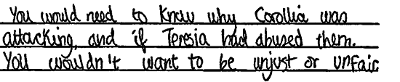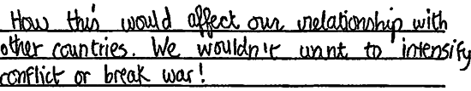
-------------------------------------------------------------------------------------------------------------------------------------------------------------------------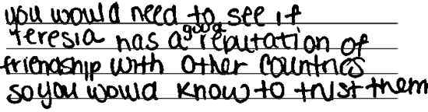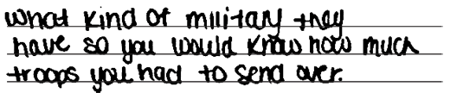
The response suggests two useful pieces of information and explains why each would be important.The response suggests two useful pieces of information and explains why each would be important.

ACCEPTABLE - Student Response

-------------------------------------------------------------------------------------------------------------------------------------------------------------------------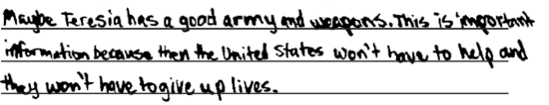

For this response, the two pieces of information provided were taken to be two sides of the same idea, i.e., the relative strength of the two parties involved in the conflict. Similarly, the explanation, though not as clearly articulated as it could have been, was read to mean that you should know the strength of the opposing forces to gauge the risk to the U.S. military. The response received a score of Acceptable, but is an example of a weak paper at that level.The response identifies two pieces of information that would be useful but only explains the importance of the first one. The explanation for the second one could be same as the first, but it is not stateed and therefore cannot receive credit.

PARTIAL - Student Response
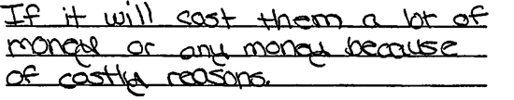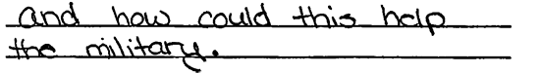
-------------------------------------------------------------------------------------------------------------------------------------------------------------------------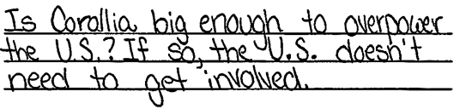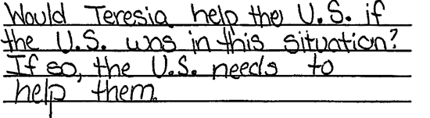
The response identifies one piece of useful information--the possible financial cost to the U.S.--but the explanation is insufficient. The second piece of information identified is not clearly enough articulated to receive credit.The response identifies two potentially useful pieces of information but the explanations are opinions about what course the U.S. should take rather than reasons why the information is important to have.

UNACCEPTABLE - Student Response
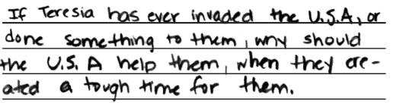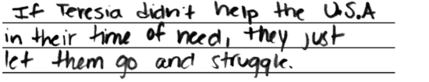
-------------------------------------------------------------------------------------------------------------------------------------------------------------------------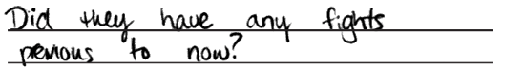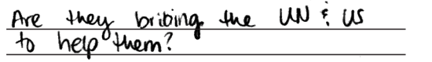

The response does not identify any useful information or provide good reasons. The suggestions--learning whether Teresia has ever hurt the U.S. or if Teresia has ever failed to help the U.S.--would seem to be irrelevant at this point in time given the scenario's assertion that the U.S. and Teresia are currently allies.The response identifies no useful information and provides no explanations. The answers given are vague and incomplete.

- Item Detail for Question 14 - No student responses are available for this question.

- Item Detail for Question 15 - No student responses are available for this question.

- Item Detail for Question 16 - No student responses are available for this question.

- Item Detail for Question 17 - No student responses are available for this question.

- Item Detail for Question 18 - No student responses are available for this question.

- Item Detail for Question 19 - No student responses are available for this question.

