- Item Detail for Question 1

Acceptable - Student Response
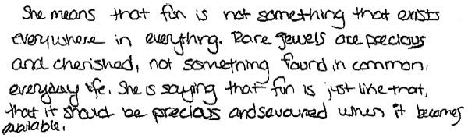
-------------------------------------------------------------------------------------------------------------------------------------------------------------------------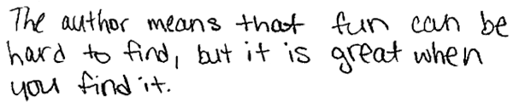
------------------------------------------------------------------------------------------------------------------------------------------------------------------------- Both responses provide reasonable explanations for what the author means by the phrase. They indicate that fun is not easy to find and is very valuable, just like a rare jewel.

Unacceptable - Student Response
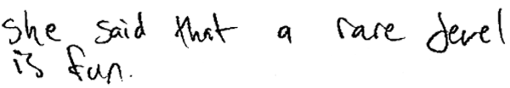
-------------------------------------------------------------------------------------------------------------------------------------------------------------------------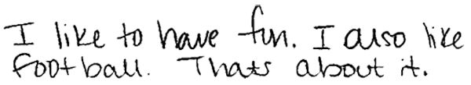
------------------------------------------------------------------------------------------------------------------------------------------------------------------------- The first response provides an inaccurate interpretation of the author's meaning. The second response provides a personal opinion about fun and does not reference the text.

- Item Detail for Question 2
No student responses are available for this question.

- Item Detail for Question 3
No student responses are available for this question.

- Item Detail for Question 4

Full Comprehension - Student Response
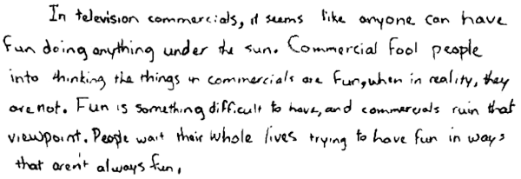

-------------------------------------------------------------------------------------------------------------------------------------------------------------------------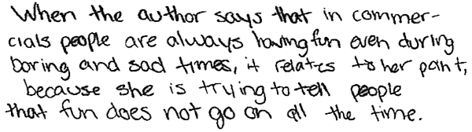
------------------------------------------------------------------------------------------------------------------------------------------------------------------------- Both responses explain how the paragraph about television commercials relates to the author's view of fun. The first response indicates that fun is difficult to find. The second response says that fun does not happen all the time.
Partial Comprehension - Student Response
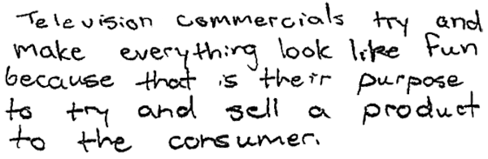
-------------------------------------------------------------------------------------------------------------------------------------------------------------------------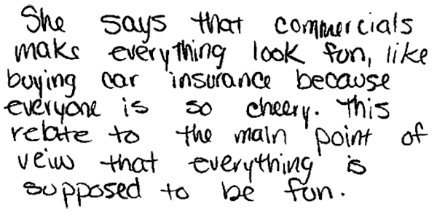
------------------------------------------------------------------------------------------------------------------------------------------------------------------------- Both responses describe the purpose of television commercials but do not relate them to the author's main point about fun. The second response provides an inaccurate interpretation of the author's main point.

Little or No Comprehension - Student Response
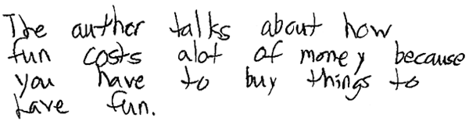
-------------------------------------------------------------------------------------------------------------------------------------------------------------------------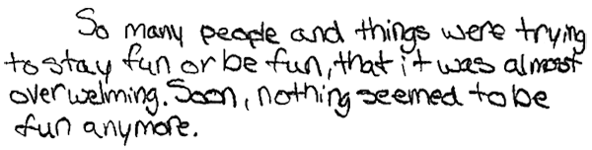
------------------------------------------------------------------------------------------------------------------------------------------------------------------------- The first response provides incorrect information about the author's view of fun. The second response provides irrelevant details that do not relate to the paragraph about television commercials.

- Item Detail for Question 5
No student responses are available for this question.

- Item Detail for Question 6

Extensive - Student Response
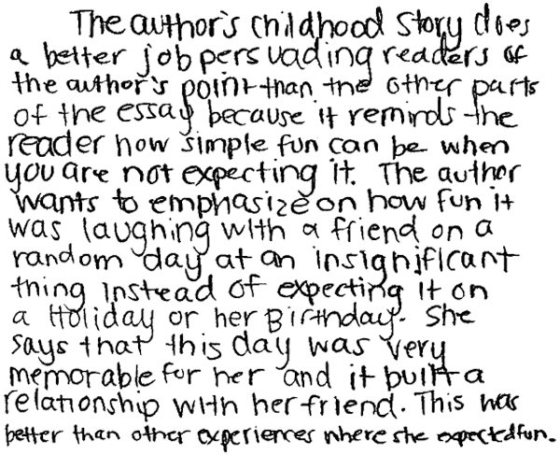
-------------------------------------------------------------------------------------------------------------------------------------------------------------------------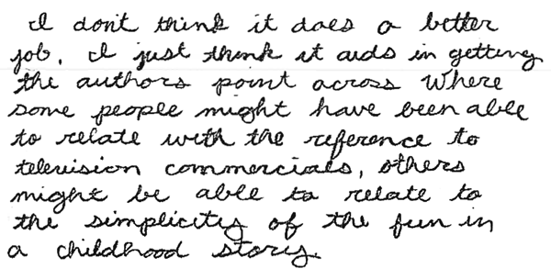
------------------------------------------------------------------------------------------------------------------------------------------------------------------------- Both responses support an opinion about whether the childhood story is more persuasive and explain with reference to both the childhood story and other parts of the essay. The first response argues that the childhood story does a better job because it functions to remind the reader and emphasize the author's main point about fun being simple and unexpected as opposed to the expectations about fun attached to holidays and birthdays. The second response points out that the ending with the childhood story may appeal to different readers of the essay, whereas the examples of commercials may have worked more effectively for other readers.

Essential - Student Response
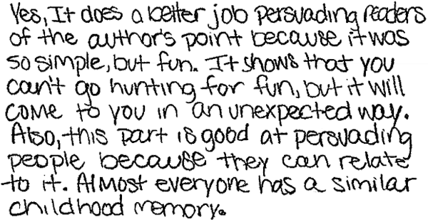
-------------------------------------------------------------------------------------------------------------------------------------------------------------------------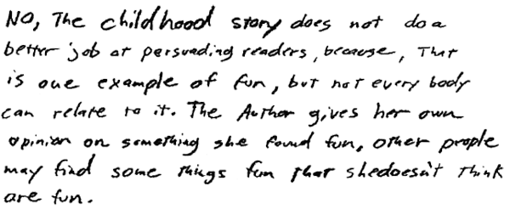
------------------------------------------------------------------------------------------------------------------------------------------------------------------------- The first response argues that the childhood story did a better job of persuading readers because many people would have a similar childhood story. The second response takes the opposite opinion, seeing the childhood story as too personally related to the author. Both responses focus only on the ending and make no reference to other parts of the essay.

Partial - Student Response
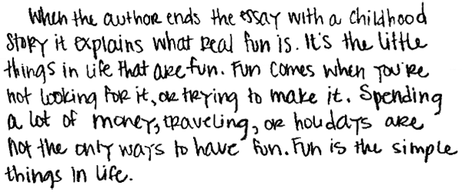
-------------------------------------------------------------------------------------------------------------------------------------------------------------------------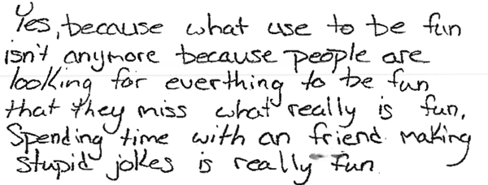
-------------------------------------------------------------------------------------------------------------------------------------------------------------------------Neither response discusses the persuasiveness of the childhood story or other parts of the essay. The first response interprets the childhood story. The second response provides a "Yes" opinion, but discusses the author's main point about fun, not the author's persuasiveness.

Unsatisfactory - Student Response
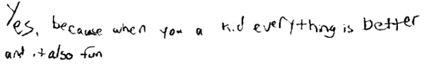
-------------------------------------------------------------------------------------------------------------------------------------------------------------------------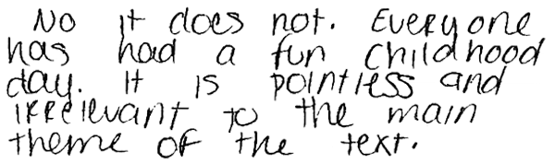
------------------------------------------------------------------------------------------------------------------------------------------------------------------------- The first response provides an unsupported personal opinion about childhood and fun. The second response provides inaccurate information about the story and its relationship to the author's point.

- Item Detail for Question 7
No student responses are available for this question.
- Item Detail for Question 8

No student responses are available for this question.
- Item Detail for Question 9

Full Comprehension - Student Response
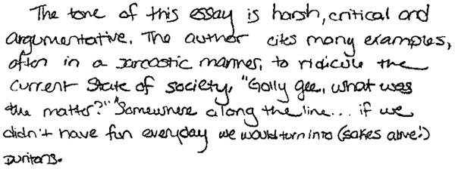
-------------------------------------------------------------------------------------------------------------------------------------------------------------------------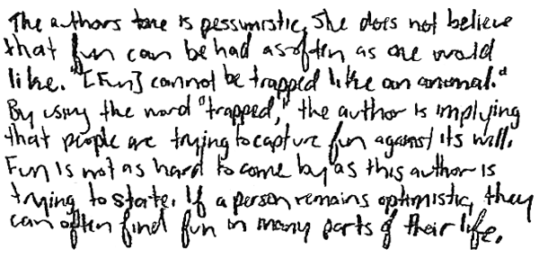
------------------------------------------------------------------------------------------------------------------------------------------------------------------------- Both responses describe a plausible author's tone and explain the tone with specific reference to the essay. The first response references two quotations from the essay that support sarcastic. The second response explains a pessimistic tone by focusing on the author's word choice in presenting a main idea of the essay.

Partial Comprehension - Student Response
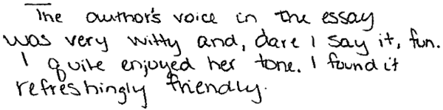
-------------------------------------------------------------------------------------------------------------------------------------------------------------------------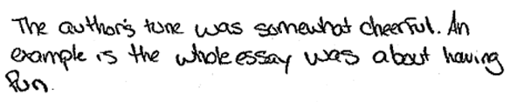
------------------------------------------------------------------------------------------------------------------------------------------------------------------------- The first response describes a plausible author's tone but does not explain the choice with any support from the essay. The second response provides a plausible tone, but the example is a general statement about the topic of the essay that does not support or explain "somewhat cheerful."

Little or No Comprehension - Student Response
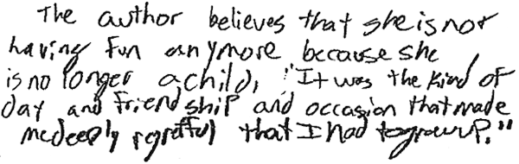
-------------------------------------------------------------------------------------------------------------------------------------------------------------------------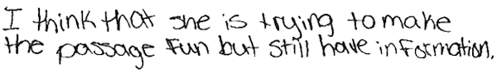
-------------------------------------------------------------------------------------------------------------------------------------------------------------------------Neither response describes the author's tone or voice. The first response provides a misinterpretation of why the author includes the childhood story. The second response provides a personal opinion about the author's purpose.

- Item Detail for Question 10
No student responses are available for this question.

