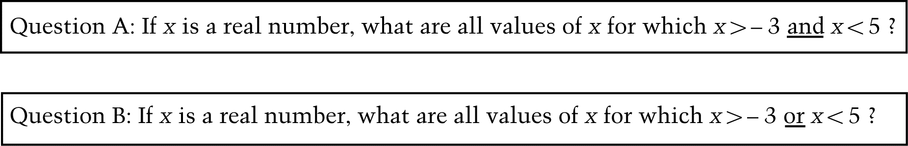

1. Barbara said that the answers to the two questions above are different.

Dave said that the answers to the two questions above are the same.

Which student is correct (mark the oval)? Barbara Dave

Explain why this student is correct. You may use words, symbols, or graphs in your explanation.

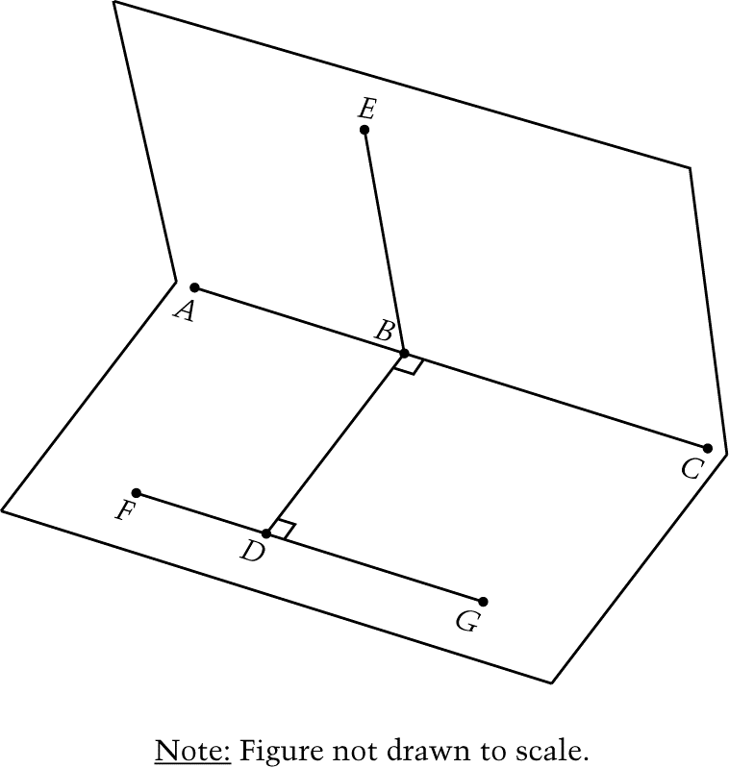
Questions 2, 3 and 4 refer to the card shown.

The card is folded along line AC so that point D coincides with point E. The card is opened so that segment BE is perpendicular to segment BD, as shown. Use the figure to answer questions 2, 3 and 4.

The lengths of some of the line segments on the card are given below.

centimeters

centimeters

centimeters

centimeters

2. What is the measure of ?

A. 30

B. 45

C. 60

D. 90

E. 135

3. What is the measure of ?

A. 30

B. 45

C. 60

D. 90

E. 180

4. What is the area of ?

Answer: ____________________ cm²

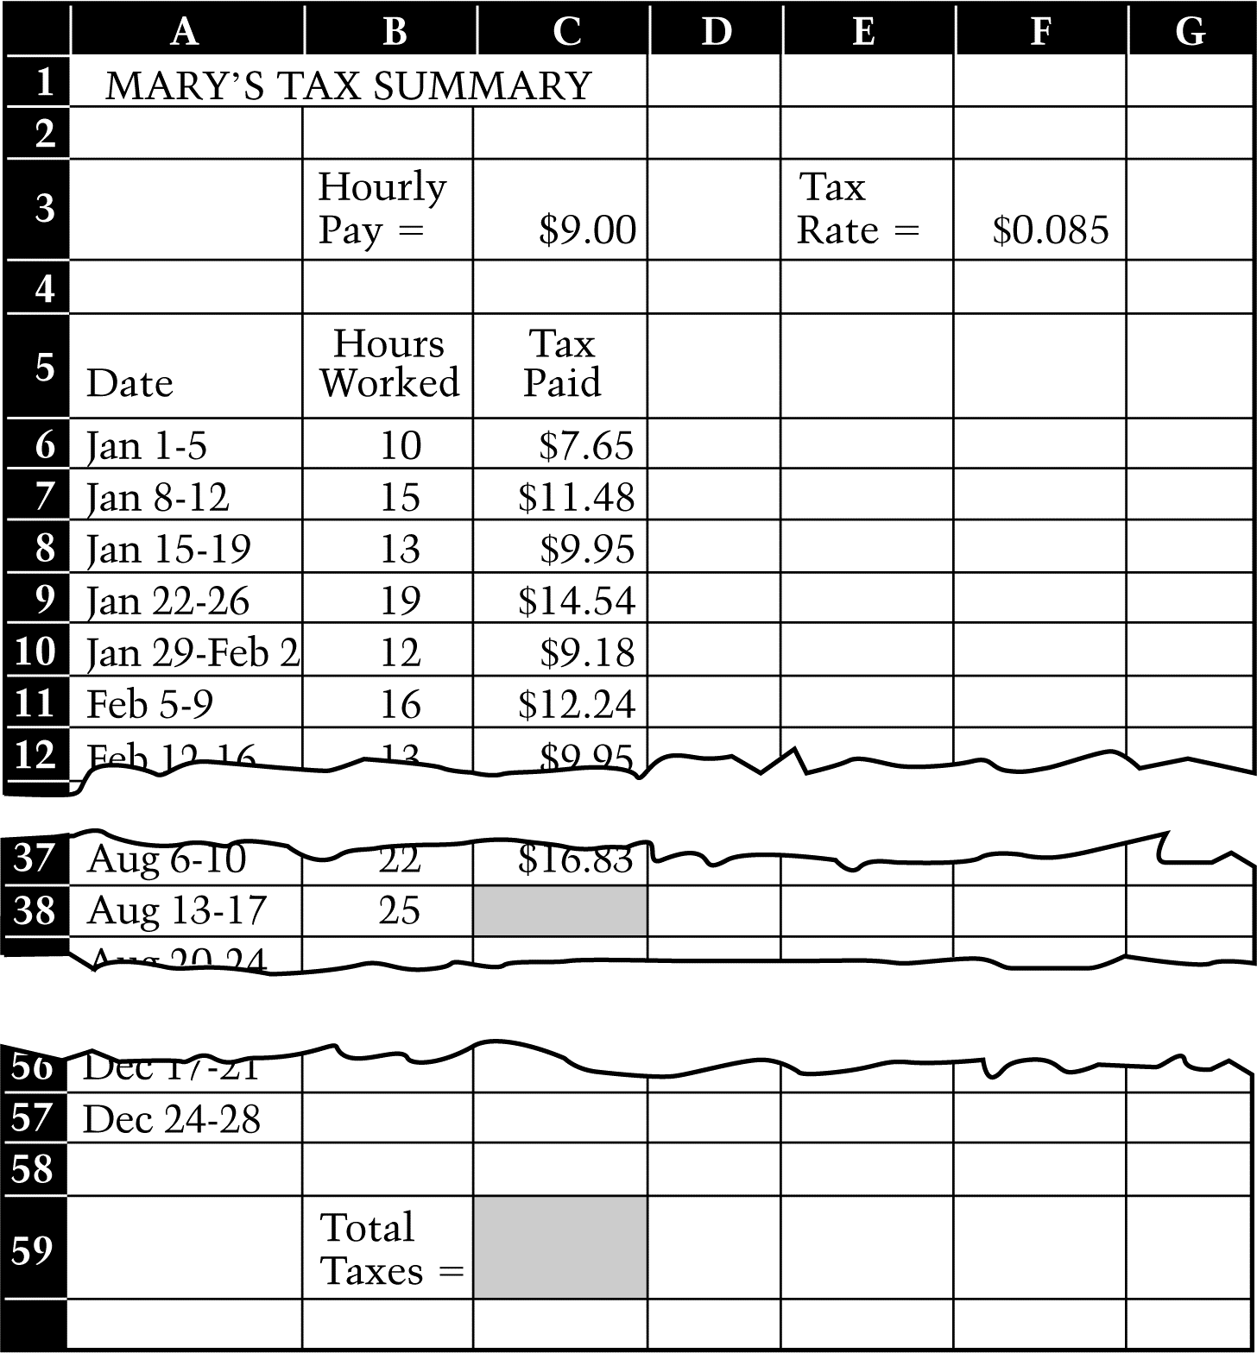
Questions 5 and 6 refer to the spreadsheet.

Mary created a spreadsheet to keep a record of the taxes she pays during the year. Mary works every week during the year. Portions of Mary’s spreadsheet are shown. The spreadsheet is set up so that Mary enters the amount of her hourly pay in cell C3 and the tax rate in cell F3. The tax rate is the number of dollars of tax paid for every dollar earned. Marys hourly pay and the tax rate do not change during the year. Each week Mary enters the number of hours she worked into the spreadsheet.

5. Which of the following spreadsheet formulas could Mary use in cell C38 to compute the amount of tax she paid on her earnings during the week of August 13 to August 17? (The amount of tax she paid each week is the product of her weekly pay and the tax rate.)

- C38 = A38 * B3 * E3

- C38 = A38 * C3 * F3

- C38 = B38 * B3 * E3

- C38 = B38 * C3 * F3

- C38 = C38 * B3 * E3

6. Write or describe a formula Mary can use in cell C59 to give the total amount of taxes paid for the year.

Answer: _______________________________________________________________________

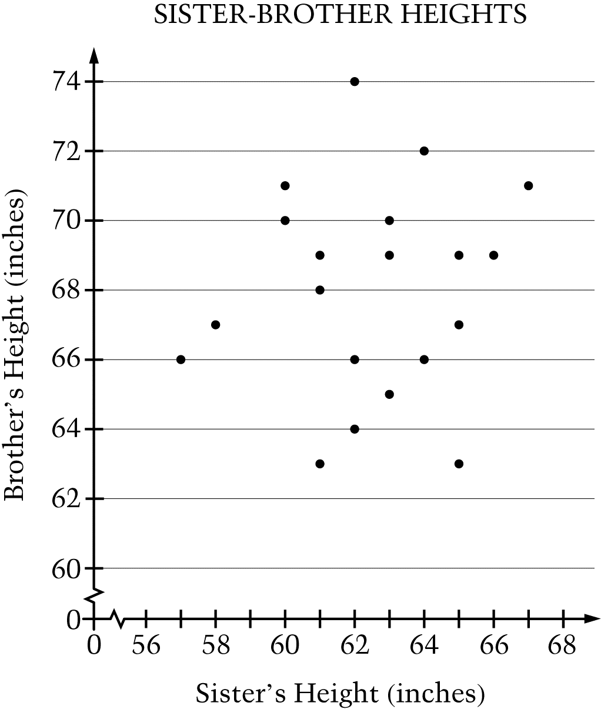
7. In the scatterplot, each point represents the adult heights of a sister-brother pair.

What is the brothers height that corresponds to the tallest sisters height?

A. 74 inches

B. 71 inches

C. 67 inches

D. 66 inches

E. 62 inches

8. If , what is ?

A. 0

B.

C. 1

D.

E.

9.

A. 512

B. 64

C. 48

D. 24

E. 12

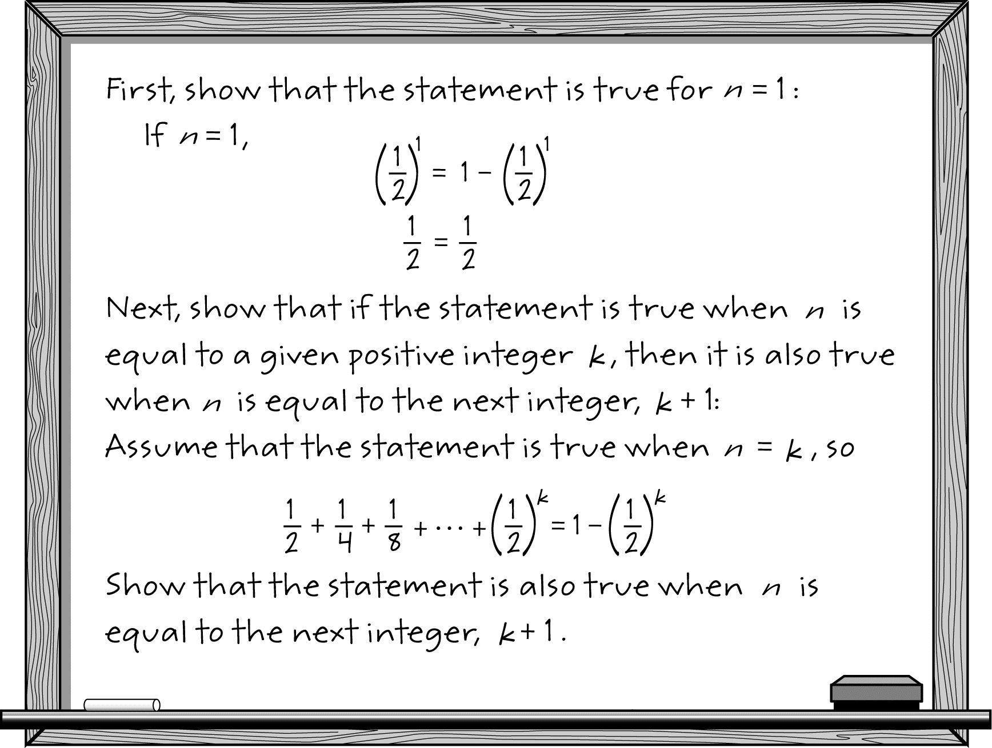
10. A student was asked to use mathematical induction to prove the following statement.

for all positive integers n

The beginning of the students proof is shown below.

Complete the students proof by showing that if the statement is true when , then it is also true when , where k is any positive integer.

