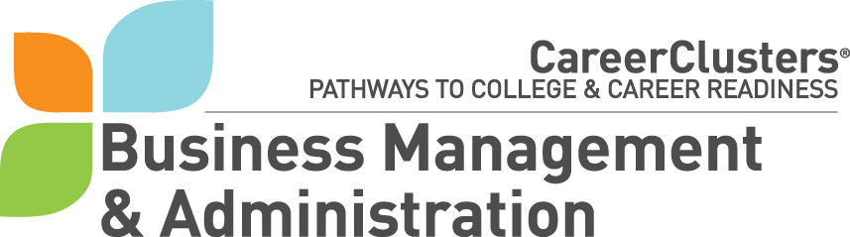 |  |  |  | Missouri  Program of Study |  |  |  | Rev: 01/20  School:  Date:
Cluster: Finance Pathway: Securities and Investments Postsecondary Option: _____ Degree Program: ______________
This Career Pathway Program of Study can serve as a guide, along with other career planning materials, as learners continue on a career path. Courses listed within this plan are recommended coursework and should be individualized to meet each learner’s educational and career goals. This Program of Study should be customized with course titles and appropriate high school graduation requirements as well as college entrance requirements. Schools are highly encouraged to offer Core 42 courses as they are accepted by most of Missouri’s two - and four - year colleges.

EDUCATION  LEVELS | GRADE | English/ Language Arts | Mathematics |  | Science | Social Studies/ Science | Other Required Courses  Recommended Electives  Learner Activities | Recommended Career and Technical Courses  Source:  https://apps.dese.mo.gov/CoreData/CareerEdApprovedCourses.aspx | SAMPLE – Occupations Relating to This Pathway: link (sorted by level of degree)
Graduation Requirements: https://dese.mo.gov/sites/default/files/QS-Graduation-Requirements-Handbook-2018.pdf |  |  |  |  |  |  |  |  | Requiring Postsecondary Education  - Brokerage Clerk  - Financial Quantitative Analysts  - Financial Specialist  - Fraud Examiner, Investigator and Analyst  - Investment Underwriter  - Sales Agent, Financial Services  - Sales Agent, Securities and Commodities  - Securities and Commodities Trader  - Securities, Commodities, and Financial Services Sales Agent  - Tax Preparers  Baccalaureate Degree +  - Compliance Manager  - Energy Broker  - Investment Fund Manager  - Investment Underwriter  - Personal Financial Advisor  - Risk Management Specialist
MIDDLE | 7
MIDDLE | 8
SECONDARY | 9 | English/Language Arts I | Algebra I |  | Earth or Environmental Science | Missouri History  Civics | Meet local and state graduation requirements along with college entrance requirements.  Supervised Business Experience (SBE) | - Accounting I  - Accounting II  - AP Macroeconomics  - AP Microeconomics  - Banking and Financial Services  - Business Economics  - Personal Finance
SECONDARY | 10 | English/Language Arts II | Geometry |  | Biology | U.S. History
SECONDARY | 11 | English/Language Arts III | Algebra I or other math |  | Chemistry or other science | World History
SECONDARY | Placement Assessments- Academic/Career Advisement Provided
SECONDARY | 12 | English/Language Arts IV | Statistics
SECONDARY | High school courses in the pathway offered locally for college credit should be coded: Advanced Placement (AP), International Baccalaureate (IB), Dual Enrollment (DE), and / or AC (Articulated Credit)
List related certifications/credentials approved by DESE and offered locally:  - Concepts of Finance – ASK Institute |  |  |  |  |  | Additional Learning Opportunities:  CTSO Organization(s): DECA FBLA FCCLA FFA  HOSA SkillsUSA TSA Educators Rising  Other:  Work-Based Learning:  Career Research Cooperative Education Internship Mentorship  Job Shadowing Service Learning Project Student Apprenticeship

 |  |  |  |  |  | Page 2
Postsecondary Option:
POSTSECONDARY | Year | English | Mathematics | Science | Social  Studies |  | Required Courses or Recommended Electives
POSTSECONDARY | Year 13
POSTSECONDARY | Year 14
POSTSECONDARY | Year 15
POSTSECONDARY | Year 16

